***Longhorn Phone Company***

**PROJECT SCOPE STATEMENT**

Note: Any work not explicitly included in this Project Scope Statement is implicitly excluded from the project.

**Executive Summary**

The project aims to upgrade the technology used by the employees of Longhorn Phone Corporation by migrating the most used applications within its offices onto a secure private cloud while maintaining security. The move is aimed at providing efficient systems that provide security to both the client data and intellectual property of the company while providing better services.

The scope of the project includes making this transition smooth, without disrupting any previous functionality of the applications to be migrated. The team aims to test and implement each process, of making the move, at the enterprise level. The thin-client desktops for the technology upgrade are being outsourced from an external vendor and are outside of the scope of this project. This project will allow users to access their work from anywhere without being restricted to their table desktops, leading to more efficiency and effectiveness of work.

**Business Value**

We, at Longhorn Phone Corporation, believe innovation to be the cornerstone for providing the best and latest services to our customers. With a work culture that promotes ideation and implementation, our employees are led to increased productivity and organizational effectiveness. We believe in moving with the times and using the best technology to provide our employees and customers with the most value propositioned solutions.

***Tactical Value***

The tactical value is to introduce technology that is secure, efficient, and effective. We look forward to implementing a migration of systems that allows more security for our data, more productivity to work propositions, and ease of function. Our aim is to make a clear transition to a secure, easily accessible system that increases effectiveness of operations while providing top service to our customers and employees. With the current project we aim to equip 500 employees with state of the art access to work with additional computing speed.

***Strategic Value***

Longhorn Corporation aims to use technology that creates value for its users and employees in the most effective manner. We look to keep implementing and upgrading softwares to allow for introducing more groundbreaking services in the future and create value. Basing decisions on innovative technologies, we plan to, as an organization, look forward to introduce upgrades that place us at strategic place in the market.

**Product Scope**

***Description of Product Solution***

The final product consists of an on premise, private cloud, a secure way to connect to this client from the new thin-client desktops, and applications running on the cloud instead of desktops. Installing the actual desktops themselves is not part of the scope of this project team; however, it does tie in with the final product.

* New server
* Secure server that can act as a cloud
* Secure method of connecting to the private cloud
* Reliable method of connecting to the private cloud
* Applications successfully running on the cloud
  + Word Processing Application
  + Publishing
  + Spreadsheets
  + Presentations Software
  + Sharepoint Sites
  + Financial Services (Accounts Payable, Accounts Receivable)
  + Customer Relations Management

***Work Breakdown Structure***

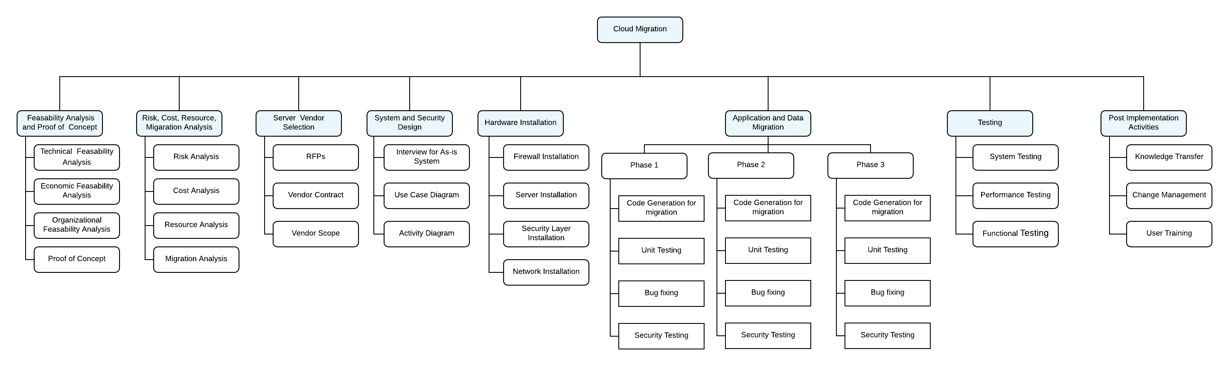

***Business Requirements***

There are a few business requirements facilitating this migration to the cloud.

1. Customer data needs to be secured.

Customer data needs to be protected. Therefore, hosting a private, on-site cloud was deemed the best solution to meet this business need because there is additional security surrounding the cloud. There are many successful cyber-attacks occurring, and competition is too stiff for Longhorn Phone Company to endure reputational damage due to a data breach.

1. Employees need to interface with the latest technologies to be efficient.

Longhorn Phone Corporation’s employees have been using outdated desktops and outdated technologies for some time now. It causes delays and money to be lost.

1. Employees need to be able to collaborate from different locations.

As time changes and business requirements change employees are being forced to work from outside the office more. Whether it’s to meet a client and work from there site or to present something to a client to having to work from home because of personal issues, working from outside the office is common, and Longhorn Phone Corporation needs to be able to provide for that.

**Project Scope**

***Project Management Approach***

The project will take a hybrid of agile and iterative methodologies. For example, a lot of research will be done beforehand on the requirements and which server to buy because once a server is bought, it is bought. However for the actual migration, it will be done in pieces. First, the main chunk of the migration will be done. Then there will be three rounds of feedback to improve the applications’, functionalities, speed, etc. Simultaneously, security will be implemented with every phase and be followed by three rounds of finding weaknesses and improving upon them.

***Project Management Deliverables***

* Project Charter
* Project Scope Statement
* Budget
* Schedule
* Stakeholder Analysis
* Work Breakdown Structure
* Quality Plan
* Communication Plan
* Change Management Plan
* Risk Management Plan

***Staff Management Deliverables***

* Responsibility Assignment Matrix
  + This clarifies who has what responsibility, but also helps the project manager see that one person does not have an overwhelming amount of work.
* Team Meetings
  + This is to get everyone on the same page to create a big picture in terms of project progress. It also is to help communication, and foresee any upcoming obstacles
* Status Reports
  + Status reports from each team member to update the project manager on his or her weekly activities and report and upcoming obstacles.

***Other Administrative Deliverables***

* Risk Management Plan
* Change Management Plan
* Budget
* Biweekly Project Report
  + This is a project report for management highlight if the project is on time and on budget, the accomplishments, and the challenges.
* Quality Audit
  + This is to prove to management the quality of work is satisfactory and meets all requirements
* Server Manual
  + This is a manual with instructions on how to maintain the on-premise server in terms of functionality and safety.

**Other Relevant Scope Information**

***External Factors***

* Regulatory
  + Currently, there are no regulatory requirements on telecommunication data; however, any changes to the regulatory environment could affect the project.
* Breaks
  + Longhorn Phone Corporation has a generous break and holiday schedule to prevent burn out. This means workers can get paid time off without giving a notice in advance which can affect the pace of the project.

***Project Completion Criteria***

* The server must be installed.
* The server must be connected to the desktops in a secure fashion.
* The server must host the applications and their data.
* The server must be secure.
* The applications must run successfully on the server.

***External Dependencies***

The project does rely on the support of the sponsor, Ted Tele-O’Fone

***Project Dependencies***

Internally, certain parts of the project depend on other parts of the project.

* The new thin-client desktops have to be installed before creating the secure connection to the private cloud.
* The server has to be installed before creating the connection to the clients and configuring the cloud.

***Assumptions***

* The storage offered in the Cloud should be sufficient to hold the upgraded and migration data.
* During the transition between systems, the business functions will remain unaffected.
* The move will not affect the functionality of the applications.
* The number of users are scalable depending on the required strength.
* The applications upgraded to the private cloud will be secure.

***Constraints***

* Resource distribution from the parent company ie. Longhorn Phone Conversation.
* Any issues and complaints faced due to the updated system should be reported within a period of two weeks.
* The project needs to be completed in 6 months.
* Third party softwares cannot be used by users without prior approval.

**Out of Scope**

* Change requests outside after the completion of the project. Change requests are only accepted in the form of feedback during the three feedback loops.
* The actual installation of the desktops.
* Two-factor authentication or any type of security to log in to the thin-client.
* Backing up data from the on-premise cloud to another third party cloud for data redundancy and business continuity.

**Acceptance Criteria**

***Project phases and exit criteria***

|  |  |
| --- | --- |
| ***Phase*** | ***Exit Criteria*** |
| Feasibility Analysis | System Specifications |
| Vendor Selection | Vendor Name |
| Proof of Concept | Successful Prototype |
| System Design | System Blueprint |
| Hardware and Security Installation | Functioning Server |
| Migration | Successful Migration of all seven applications. |
| Testing | Passing quality audit |
| Post Implementation Procedures | Knowledge Transfer |

***Quality plan***

* The cloud will host minimum 500 users with functional scalability and applications.
* The cloud supports the following office applications: word processing, spreadsheets, publishing, presentation software, sharepoint sites, CRM and financial services such as accounts receivable and accounts payable.
* Thin client computers access the cloud under a (name of security technology) secure environment.
* Applications run on the cloud with (following speed/computing power)
* Five-hundred users can access the applications at the same time.
* Information is secured using (security technology)
* The functionality and user interface of application is same as before.

***Signatures***

Sponsor _________________________________

Management _________________________________

Project Leader __________________________________